Mulesoft Anypoint Platform
Experiment 4
Aim:
Design an Employee API using total and test theme with Mock API.
Solution:
This experiment focuses on designing a real-world RESTful API for employee management using RAML (RESTful API Modeling Language) in the Design Center of MuleSoft's Anypoint Platform. After designing the API, we test it using the Mocking Service, which simulates real responses without backend implementation.
Steps:
- Navigate to https://anypoint.mulesoft.com and log in using your Anypoint credentials.
- From the main dashboard, select Design Center → Click Create New → Choose API Specification → Select RAML 1.0 format.
- Enter the project name as: Employee API
- 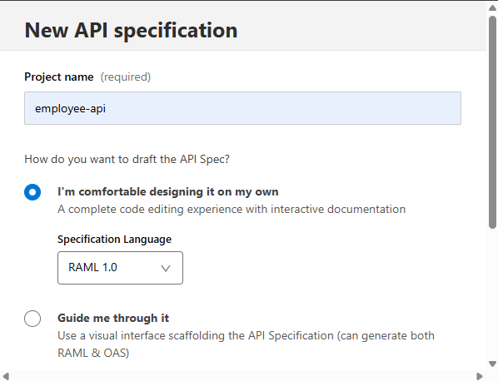

- Define API using RAML
Replace the default content with the following RAML code:
#%RAML 1.0
title: Employee API
protocols:
- HTTPS
/employee:
get:
responses:
200:
body:
application/json:
example:
[
{
"Id": 101,
"Name": "Alice Johnson",
"Role": "Developer",
"Department": {
"Name": "Engineering",
"Location": "Bangalore"
}
},
{
"Id": 102,
"Name": "Bob Smith",
"Role": "Tester",
"Department": {
"Name": "QA",
"Location": "Hyderabad"
}
}
]
- Click the Save button (top right) after entering the RAML. Anypoint Platform will validate and structure the documentation.
- In the top right corner, click Mock this API. Anypoint will generate a Mock URL.
- From the left-side panel, click on Documentation.
- Select GET /employee → Click Try It → You should receive the mock employee list.
- 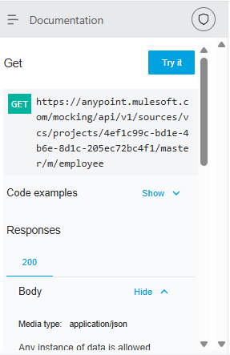
- Click on Mock Settings ➜ Share
- Enable public sharing
- 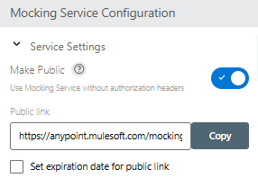
- Copy the public mock link (e.g., https://anypoint.mulesoft.com/mocking/api/v1/links/...)
- To test in Postman or browser, append /employee to the URL, like:
- https://anypoint.mulesoft.com/mocking/api/v1/links/your-link-id/employee
- Test in Postman
- For GET: Use the above URL with GET method — no headers/body needed
- You will get a output like this:
- 